DOCKER INSTALLATION STEPS
Step-1:
- $ sudo apt update
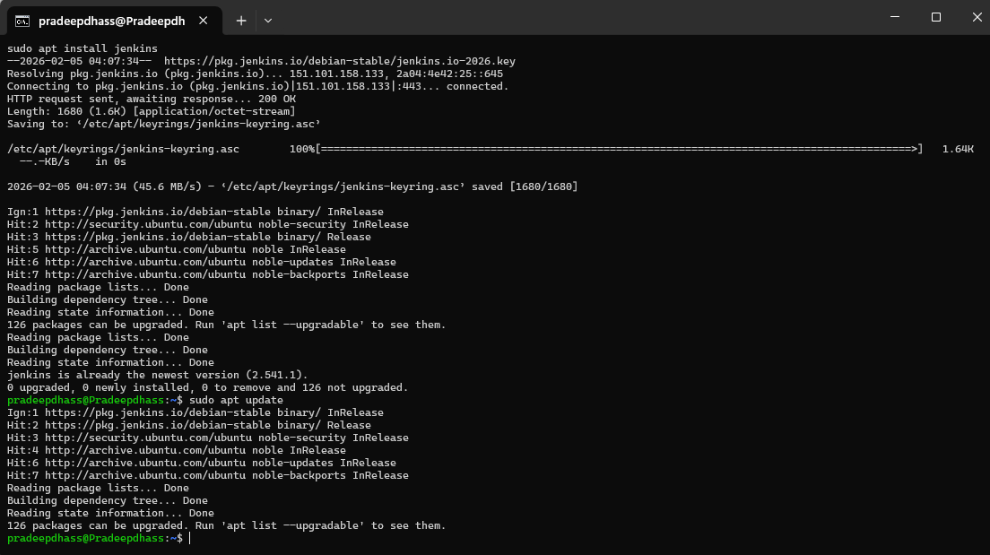

Step-2:
- $ sudo apt install docker.io

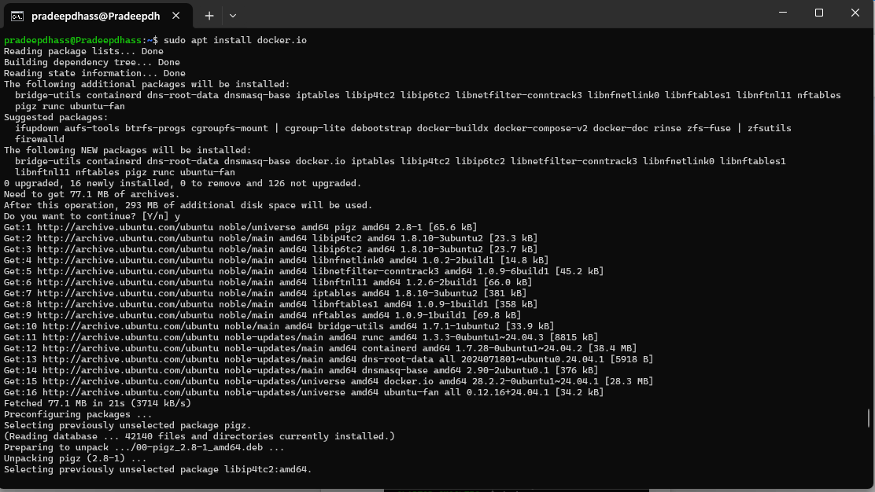

Step-3:
- $ sudo systemcall start docker

Step-4:
- $ sudo docker ps

JINKINS INSTALLATION STEPS
Step-1:
- $ sudo apt update
- $ sudo apt install fontconfig openjdk-21-jre
- $ java -version

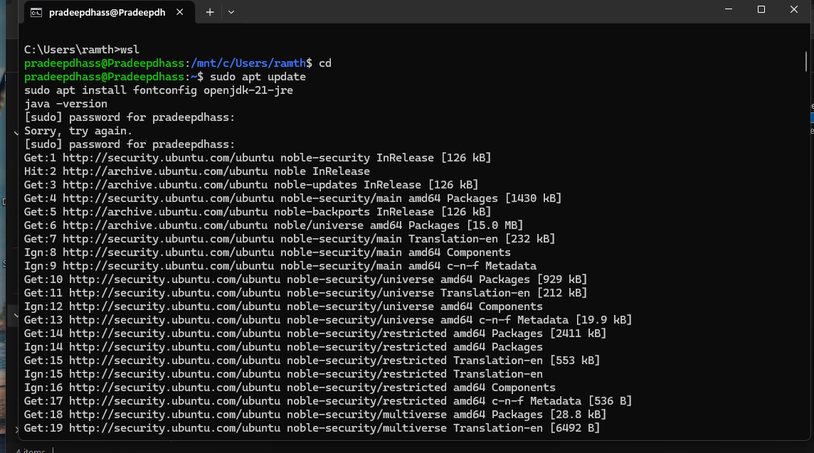

Step-2:

- $ sudo wget -O /etc/apt/keyrings/jenkins-keyring.asc \
https://pkg.jenkins.io/debian-stable/jenkins.io-2026.key
echo "deb [signed-by=/etc/apt/keyrings/jenkins-keyring.asc]" \
https://pkg.jenkins.io/debian-stable binary/ | sudo tee \
/etc/apt/sources.list.d/jenkins.list > /dev/null
- $ sudo apt update
- $ sudo apt install Jenkins

